Week In Review: January 2-9
Alex Shvartsman
Friday, January 11, 2002

Grand Prix-Houston
The new year has been launched by a Grand Prix in Texas. There is a funny thing about Texas tournaments - they seem to always be won by players from Canada. Pro Tour-Dallas was won by Canadians (both Junior and Senior divisions), as were both of the previous Grand Prix held there.
Grand Prix-Houston was a relatively small tournament, with under 300 players competing. Strangely, none of the foreign players took advantage of an opportunity to travel to Houston and go on straight to PT-San Diego from there, though several American players were traveling straight through.
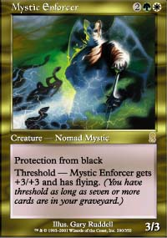
This time around, history would not repeat itself. There were no Canadians at the top of the standings. There were, however, plenty of top pros from around the country. Leading the standings after 14 rounds of Swiss was William "Baby Huey" Jensen - who played an original Oath of Druids variant with four Disrupts and four Accumulated Knowledges maindeck. He claimed his deck annihilates Miracle Grow - which was by far the most played deck in the tournament - and he was right. The only other player to enter Top 8 at 32 points was Ben Rubin, who modified the Miracle Grow deck by adding white for Swords to Plowshares and Mystic Enforcer. Brian Kibler, who entered Top 8, fifth, played the same deck.
Bob Maher surprised many by playing Sligh - a great choice against Miracle Grow, but still dangerous since it has so many bad matchups. Things worked out for Bob, and he managed to make Top 8, burning opponents out of the way. I played a more traditional version of Miracle Grow, with Withdraws main deck - a tech card Neutral Ground player Elden Lee came up with that is very powerful in the mirror. If I recall it right, this is my 14th GP Top 8 finish, more than anyone else in the world. Ryan Fuller is second with 9 GP Top 8 finishes.
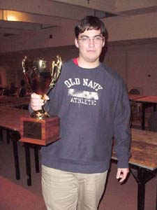
Jonathan Pechon (Junk) and Jonathan Job (Miracle Grow) rounded out the Top 8. The winner however, was not one of the high profile pro players. It was Boston's Josh Smith, who navigated an original b-u-g control deck, defeating me, Ben Rubin and Brian Kibler to battle his way through the single elimination rounds. Robert Dougherty called Smith "the best Your Move Games regular who had never qualified for the Pro Tour". No longer. Smith will now get his chance to compete in Osaka. Having played against him for an hour this Sunday, I'd say he has a good chance to do well.
Other pro players to do well in Houston but not Top 8 include Alan Comer, the man responsible for the Miracle Grow insanity himself, who finished 10th, Zvi Mowshowitz who navigated his beloved TurboLand deck to a Top 16 finish, Phil Freneau and Dan OMS in Top 16. Borteh, Benafel, Macey, Ho and Hubble all finished in the money.
The most popular deck in the tournament was Miracle Grow in its many variations. The Rock was the second most popular, but got annihilated on Day 1, with very few Rock decks making Day 2. None that I know of finished in the money, though a couple may have. I encourage those who still have Extended tournaments coming up to give another look at b-u. While I am no great fan of either Smith's deck or the Zombie-Go deck that won GP-Sendai, u-b variations are consistently fighting their way into Top 8's, and there may be a version out there that is very strong.

Today: Pro Tour-San Diego And The San Diego Masters Series

The Pro Tour saga continues this week with its first ever stop at the sunny San Diego. Although The Boat - location of Pro Tour-Los Angeles - was much beloved by PT regulars, it is hard to imagine a better city to replace it with. Players will be called upon to test their skills in Odyssey Rochester Draft - just two weeks prior to the Torment Prerelease, this will be the last tournament to feature Odyssey-only Limited format.
The most-watched player of the tournament will, of course, be Kai. Can his amazing streak continue, or will this tournament undo it? Kai displayed his skill at the format by making the finals of Grand Prix-Biarritz and he has spent a lot of time practicing on Magic Online and in real-life drafts, so he is certainly unlikely to bomb out - but will he make another Top 8?
How strong is Kai's position in the player of the year race? At the moment, I am tied for second place with Tomi Walamies, at 32 points. Even if one of us wins in San Diego, we will still be behind Kai by at least 5 points! With only ten players currently in possession of over 20 points, this race might never become exciting at all.
Jon Finkel and Kamiel Cornelissen are another pair of interesting personalities to watch. Although their competition did not get as much press ever since Budde's dominance became indubitable, it is still anyone's call as to which is a better Magic player. Finkel certainly has far more lifetime achievements, and his recent results would make most other pros envious, but Kamiel does have an unprecedented record of finishing in the money at every individual Pro Tour he ever played in.
San Diego will also feature for the first time since the Magic Invitational pro players building Standard decks. What secrets does the format hold? We shall find out.

Magicthegathering.com Launches

Wizards of the Coast have launched a new web site about all things Magic. It can be found at MagicTheGathering.com and is not targeted at the tournament players the way Sideboard is. Instead, editor Aaron Forsythe and his staff attempt to post something of interest to everyone - from casual fun gamer, to hardened pro. They have Torment card previews, storyline info, and a lot of revelations about how the game of Magic is made. The site features Mark Rosewater, Randy Buehler, Anthony Alongi and Ben Bleiweiss as regular columnists. It updates daily.

Magic Trivia
Last week's question:
Can you name two Magic cards whose names are anagrams of each other? (That is, you can change one name to another by rearranging the letters.)?
We've come up with at least four card pairs. Click on the card to see its anagram:
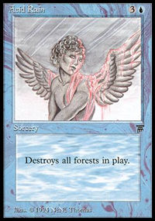 | 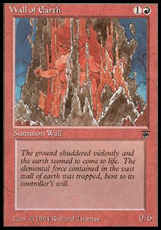
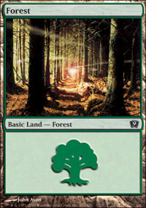 | 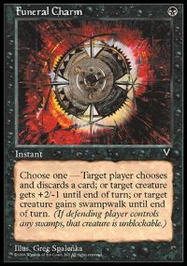
There are very likely several more!
New Question:
What Magic artist produced only one card art for Alpha and never illustrated another card after that?
Please do not email answers to me. The correct answer will be posted in the next column.

Quote of the Week
"The fastest your deck can win is, like, five weeks" - A judge discussing an unintentional draw Zvi Mowshowitz received at GP-Houston.

Play of the Week
At a side draft of Grand Prix-Houston, Jeff Taylor managed to draft a combo deck.
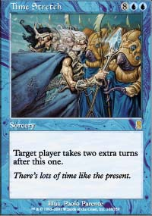
He played with Time Stretch, a pair of Anarchists and Malevolent Awakening. This is not a very fast combo, but an early Standstill bought him some time. He then cast Time Stretch and used an Anarchist to bring it back. Another Anarchist brought it back yet again, and then he proceeded to use Malevolent Awakening to trade a live Anarchist for a dead one, and take infinite turns. This may in fact have been the first Limited game where player managed to take infinite turns. Taylor placed 2nd in his draft with this deck.
Got an interesting news story, comment, quote, play of the week, or Magic trivia to report? Please e-mail me at ashv80@hotmail.com.

